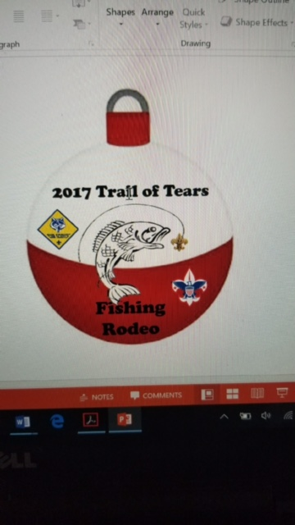

REGISTRATION: Unit/Scout online registration per instruction at double knot <http://mtcbsa.doubleknot.com/event/2017-tot-fishing-derby/2239038>

FEES: $5.00 per Cub and Boy Scout (fee includes patch, bottle water, some fishing supplies)

WHAT TO BRING: This will be bank fishing. Scouts will need to bring fishing pole, line, hooks etc., bait, stringer, if you want to take fish home bring cooler, ice and zip lock bags. Every Scout and family member will need a water bottle, Sun Screen, and insect repellent. Wear a hat.

FISH CLEANING: Cleaning stations will be set-up for those Scouts who want to clean their fish. This is a requirement for Boy Scout Fishing Merit Badge and Cub Scout Fishing Belt Loop.

SAFETY: There will be a safety and rules briefing after the check-in station.

LICENSE: Youth under 13 do not have to have a license in Tennessee. 13-15 year olds will need Jr hunt/fish license at $10.00 All over 15 need to comply with TWRA licensing requirements, <https://www.tn.gov/twra/article/fishing-license-requirements>

For additional information contact:

Jim Whitehead, 615-809-6367 or Jason Flannery, 615-294-0865

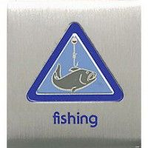

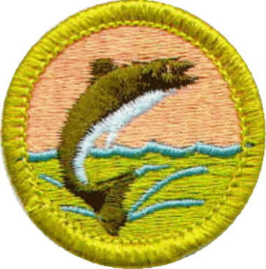

**WHEN: Saturday, November 4, 2017 9:00 AM – 2:00 PM**

**WHERE Lane Agri-Park Community Center, 315 John R. Rice Boulevard**

**WHO Cub Scouts, Boy Scouts, Parents and Family**

**WHAT Fishing Rodeo. Bass, Bream, and Catfish. Catch and release or Keep what you catch**

**TRAIL OF TEARS DISTRICT**

